

**AMERICAN INTERNATIONAL UNIVERSITY –BANGLADESH (AIUB)**

**Database Project**

**On**

**Shajahan Event Planner and Management System**

**Submitted to: Sifat Rahman Ahona**

**Section: B**

**Group Members**

|  |  |  |
| --- | --- | --- |
| **Serial No** | **Name** | **ID** |
| **1** | **Hera Sayed Abdullah** | **14-27587-3** |
| **2** | **Osmani,Sabbir Ahmed** | **18-37313-1** |
| **3** | **Shieam MD Ahannab Shakil** | **18-38027-2** |
| **4** | **Md.Sajedul Islam** | **18-37361-1** |

Introduction

The project is all about making a database for Shajahan event planner and management system. Here we will be sorting all information of planners, customers, event manager and other co-worker. Shajahan is an event management system that organized many types of in-house events. This database is efficient for an event management system like Shajahan.

Case statement

Shajahan event planner and management limited have few groups of people whose planning and work organize a successful event .The event manager gives direction to those people .Our database system stores manager’s name, address, email, phone number .Customer deals with the manager to help them organize and event and the manager keeps customer’s id, name, address, gender, email, phone, event type and date. Event manager handle group of planner, who makes better plan to make event more gorgeous, charming and efficient .Every planner has planner-id, name, address, email, phone number. Planner set all the group to work in their position and keep info of caterers, photographer / videographer and decorator. Planner store details of caterers and photographer/videographer id , name ,address, gender, email, phone number .Decorator manages electrician , florist and light-man .Decorator has id, name , address, email, phone .Decorator keeps information of electrician, florist, light-man (id, name, email, address and phone number)

ER-Diagram

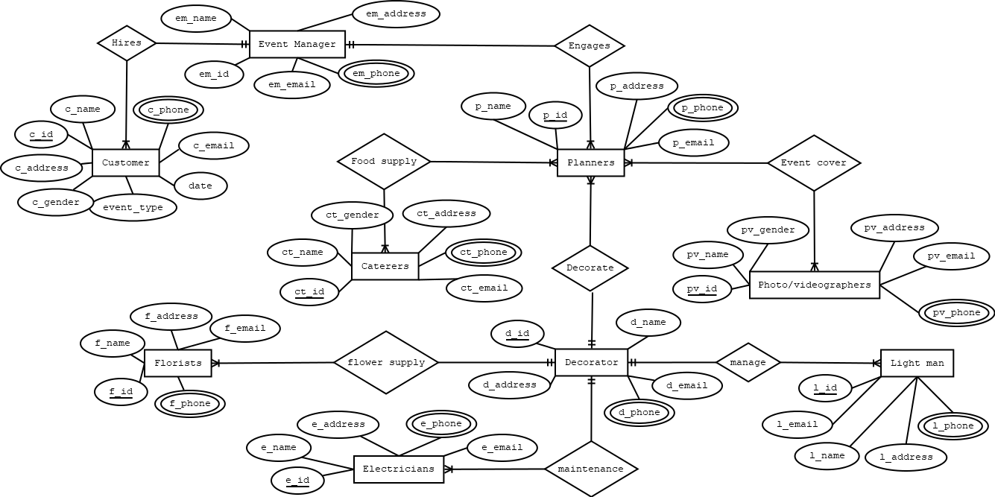

Normalization

Relation: Hires(c_id, c_name, c_address, c_gender, c_phone, c_email, date,

event_type, em id, em_name, em_address, em_phone, em_email)

1NF: c phone, em_phone are multivalued attribute.

2NF: c id, c_name, c_address, c_gender, c_phone, c_email, data, event_type, em_id.

em id , em_name, em_address, em_phone, em_email.

3NF: No transitive dependency

Table: c id, c_name, c_address, c_gender, c_phone, c_email, data,event_type, em_id.

em id,em_name, em_address, em_phone, em_email.

Relation : Engages(em id, em_name, em_address, em_email, em_phone, p id,p_name, p_address, p_email, p_phone)

1NF: em_phone, p_phone are multivalued attribute.

2NF: em id, em_name, em_address, em_email, em_phone.

p id, p_name, p_address, p_email, p_phone, em_id.

3NF: No transitive dependency.

Tables: em id, em_name, em_ address, em_email, em_ phone. p id, p_name, p address, p_email, p_phone, em_id

Relation: Foods supply(ct id, ct_name, ct_gender, ct_address,

ct_email, ct_phone, p id, p_ name, p_ address, p_email, p_phone.)

1NF: ct_phone, p_phone are multivalued attribute.

2NF: ct id, ct_name, ct_gender, ct_address, ct_email, ct_phone.

p id, p_name, p_address, p_email, p_phone

pct id, ct_id, p_id.

3NF: No transitive dependency.

Tables: ct id, ct name, ct_gender, ct_address, ct_email, ct_phone.

p id, p_name, p_address, p_email, p_phone

pct id, ct_id, p_id.

Relation: Event cover (pv id, pv_name, pv_gender, pv_address, pv_email,

pv_phone, p id, p_name, p_address, p_email, p_phone)

1NF: p_phone, pv_phone are multivalued attribute.

2NF: pv id, pv_name, pv_gender, pv_address, pv_ emai,pv_phone.

p id, P name, p.adress,p,_email, p_ phane.

ppv id, pv_id, p_id.

3NF: No transitive dependency.

Tables: pv id, pv_name, pv_gender, pv_address, pv_email, pv_phone.

p id, p_name, p_ address, p_email, p_phone.

ppv id, pv_id, p_ id.

Relation: Decorate ( p id, p_name, p_address, p_email, p_phone, d id

d_name, d_address, d_email, d_phone)

1NF: p_phone, d_phone are multivalued attribute.

2NF: p id, p_name, p_address, p_ email, P_phone, d_id.

d_id, d_name, d_address, d_email, d_phone.

3NF: No transitive dependency.

Table: p id, p_name, p_address, p_ email, P_phone, d_id.

d_id, d_name, d_address, d_email, d_phone.

Relation: Flower supply( f id, f_name, f_address, f_email, f_phone, d id, d-name,

d_address, d_email, d_phone)

1NF: f_phone, d_phone are multivalued attribute.

2NF: f id, f_name, f_address, f_email, f_phone, d_id.

d id, d-name, d_address, d_email, d_phone.

Tables: f id, f_name, f_address, f_email, f_phone, d_id d id, d_name, d_address, d_email, d_phone

Relation: Manage( I id, I_name, I_address, l_email, I_phone, d id, d _name,

D_address, d_email, d_phone)

1NF: L_phone, d_phone are multivalued attribute.

2NF: L id, I name, L_address, I_email, Lphone, d_id. d id, d-name, d_address, d_email, d_phone.

3NF: No transitive dependency.

Tables: I id, Iname, I_address, Lemail, Iphone, d_id. d id, d-name,d address, d_email, d_phone.

Relation: maintaince ( e id, e_name, e_address, e_email, e_phone, d id, d name,d_address, d_email, d_phone)

1NF: e_phone, d_phone are multivalued attribute.

2NF: e id, e_name, e_address, e_email, e_phone, d_id.

d id, d_name, d_address, d_email, d_phone.

3NF: No transitive dependency

Tables: e id, e_name, e_address, e_email, e_phone, d_id. d id, d_name, d_address, d_email, d_phone.

Total tables:

1. c id, c_name, c_address, c_gender, c_phone, c_email, data,

event_type, em_id.

2. em id, em_name, em_address, em_phone, em_email.

3. em id, em_name, em_address, em_email, em_phone.

4. p id, p_name, p_ address, p_email, p_phone, em_id.

5. ct id, ct_name, ct_gender, ct_address, ct_email,ct phone.

6. p id, p_name, p_address, p_email, p_phone

7. pct id, ct_id, p_id.8. py id, pv_name, pv gender, pv address, pv_email, pv_phone.

9. p id, p_name, p_address, p_email, p_phone.

10,ppv id, pv_id, p_id.

11.p id, p_name, p_address, p_email, p_phone, d_id.

12. d id, d_name, d_address, d_email, d_phone.

13. f id, f_name, f_address, f_email, f_phone, d_id

14. d id, d-name, d_address, d_email, d_phone.

15. I id, I_name, Laddress, I_email, Lphone, d_id.

16. d id, d-name, d_address, d_email, d_phone.

17. e id, e_name, e_address, e_email, e_phone, d_id.

18.d id, d_name, d_address, d_email, d_phone.

Final Table

1. c id, c_name, c_address, c_gender, c phone, c_email,date, event_type,

em_id.

2. em id ,em_name, em_address, em_phone, em_email.

3. p id, p_name, p_address, p_email, p_phone, em_id.

4. ct id, ct_name, ct_gender, ct_address, ct_email,ct_phone.

5. pct id, ct_ id, p_id.

6. pv id, pv_name, pv_gender, pv_address, pv_email, pv_phone.

7. p id, p_name, p_address, p_email, p_phone.

8. ppv id, pv_id, p_id.

9. d id, d_name, d_address, d_email, d_phone.

10. f id, f_name, f_address, f_email, f_phone, d_id.

11. I id, I_name, Laddress, ILemail, Lphone, d_id.

12. e id, e_name, e_address, e_email, e_phone, d_id.

Table creation and value insertion

create table customers

(

customers_id number(10) primary key,

customers_name varchar2(20),

customers_address varchar2(20),

customers_gender varchar2(6),

customers_phone number(11),

customers_email varchar2(50),

event_date date,

event_type varchar2(20),

event_manager_id number(10),

foreign key(event_manager_id) references event_manager(event_manager_id)

)

create sequence customersid

increment by 1

start with 201

maxvalue 205

nocache

nocycle

insert into customers

(customers_id,customers_name,customers_address,customers_gender,customers_phone,customers_email,event_date,event_type,event_manager_id)

values(customersid.nextval,'heera','norshingdi','male','01723456789','heera@gmail.com','16-april-2019','marriage_anniversary','100')

insert into customers

(customers_id,customers_name,customers_address,customers_gender,customers_phone,customers_email,event_date,event_type,event_manager_id)

values(customersid.nextval,'ahanab','uttara','male','01723456222','ahanab@gmail.com','20-april-2019','marriage_ ceremony','100')

insert into customers

(customers_id,customers_name,customers_address,customers_gender,customers_phone,customers_email,event_date,event_type,event_manager_id)

values(customersid.nextval,'sajedul','bashundhara','male','01723456333','sajedul@gmail.com','16-may-2019','marriage_anniversary','100')

insert into customers

(customers_id,customers_name,customers_address,customers_gender,customers_phone,customers_email,event_date,event_type,event_manager_id)

values(customersid.nextval,'ahona','dhaka','female','01901928376','ahona@gmail.com','16-june-2019','birthday','100')

insert into customers

(customers_id,customers_name,customers_address,customers_gender,customers_phone,customers_email,event_date,event_type,event_manager_id)

values(customersid.nextval,'faysal','narayanganj','male','01723456456','faysal@gmail.com','14-april-2019','marriage_anniversary','100')

create table event_manager

(

event_manager_id number(10) primary key,

event_manager_name varchar2(20),

event_manager_address varchar2(20),

event_manager_phone number(11),

event_manager_email varchar2(50)

)

insert into event_manager

( event_manager_id,event_manager_name,event_manager_address,event_manager_phone,event_manager_email)

values( '100','sabbir','uttara','01728318749','sabbir@gmail.com')

create table planners

(

planners_id number(10) primary key,

planners_name varchar2(20),

planners_address varchar2(20),

planners_email varchar2(50),

planners_phone number(11),

event_manager_id number(10),

foreign key(event_manager_id) references event_manager(event_manager_id)

)

insert into planners

( planners_id,planners_name,planners_address,planners_email,planners_phone,event_manager_id)

values( '301','raihan','bashundhara','raihan@gmail.com','017892765432','100')

insert into planners

( planners_id,planners_name,planners_address,planners_email,planners_phone,event_manager_id)

values( '302','imran','gulshan','imran@gmail.com','019292765432','100')

insert into planners

( planners_id,planners_name,planners_address,planners_email,planners_phone,event_manager_id)

values( 303','susmita','mohammodpur','susmita@gmail.com','019992765432','100')

insert into planners

( planners_id,planners_name,planners_address,planners_email,planners_phone,event_manager_id)

values( '304','jubayer','khilkhet','jubayer@gmail.com','018888765432','100')

insert into planners

( planners_id,planners_name,planners_address,planners_email,planners_phone,event_manager_id)

values( '305','alamin','mirpur','alamin@gmail.com','017892765442','100')

create table caterers

(

caterers_id number(10) primary key,

caterers_name varchar2(20),

caterers_gender varchar2(6),

caterers_address varchar2(20),

caterers_email varchar2(50),

caterers_phone number(11)

)

insert into caterers

( caterers_id, caterers_name, caterers_gender, caterers_address, caterers_email, caterers_phone )

values ('401', 'babulal', 'male', 'lalbagh', 'babulal@gmail.com', '01919214544')

insert into caterers

( caterers_id, caterers_name, caterers_gender, caterers_address, caterers_email, caterers_phone )

values ('402', 'noor', 'male', 'mirpur', 'noor@gmail.com', '01919213334')

insert into caterers

( caterers_id, caterers_name, caterers_gender, caterers_address, caterers_email, caterers_phone )

values ('403', 'neel', 'female', 'uttara', 'neel@gmail.com', '01779214544')

insert into caterers

( caterers_id, caterers_name, caterers_gender, caterers_address, caterers_email, caterers_phone )

values ('404', 'aniqa', 'female', 'bashundhara', 'aniqa@gmail.com', '01889214544')

insert into caterers

( caterers_id, caterers_name, caterers_gender, caterers_address, caterers_email, caterers_phone )

values ('405', 'shamim', 'male', 'badda', 'shamim@gmail.com', '01619214544')

create table planners_caterers

(

pct_id number(10) primary key,

caterers_id number(10),

foreign key(caterers_id) references caterers(caterers_id),

planners_id number(10),

foreign Key(planners_id) references planners(planners_id)

)

insert into planners_caterers

( pct_id, caterers_id, planners_id )

values ( '501','401','301')

insert into planners_caterers

( pct_id, caterers_id, planners_id )

values ( '502', '402', '302')

insert into planners_caterers

( pct_id, caterers_id, planners_id )

values ( '503', '403', '303')

insert into planners_caterers

( pct_id, caterers_id, planners_id )

values ( '504','404', '304' )

insert into planners_caterers

( pct_id, caterers_id, planners_id )

values ( '505','404','305')

create table photo_videographers

(

photo_videographers_id number(10) primary key,

photo_videographers_name varchar2(20),

photo_videographers_gender varchar2(6),

photo_videographers_address varchar2(20),

photo_videographers_email varchar2(50),

photo_videographers_phone number(11)

)

insert into photo_videographers

(photo_videographers_id,photo_videographers_name,photo_videographers_gender,photo_videographers_address,photo_videographers_email,photo_videographers_phone)

values('601','sourav','male','khilgaon','sourov@gmail.com','01192837465')

insert into photo_videographers

(photo_videographers_id,photo_videographers_name,photo_videographers_gender,photo_videographers_address,photo_videographers_email,photo_videographers_phone)

values('602','rafsan','male','uttara','rafsan@gmail.com','01792837465')

insert into photo_videographers

(photo_videographers_id,photo_videographers_name,photo_videographers_gender,photo_videographers_address,photo_videographers_email,photo_videographers_phone)

values('603','polash','male','khilkhet','polash@gmail.com','01882837465')

insert into photo_videographers

(photo_videographers_id,photo_videographers_name,photo_videographers_gender,photo_videographers_address,photo_videographers_email,photo_videographers_phone)

values('604','asif','male','uttara','asif@gmail.com','01772837465')

insert into photo_videographers

(photo_videographers_id,photo_videographers_name,photo_videographers_gender,photo_videographers_address,photo_videographers_email,photo_videographers_phone)

values('605','sabrina','female','mirpur','sabrina@gmail.com','01737837465')

create table planners_photo_videographers

(

ppv_id number(10) primary key,

photo_videographers_id number(10),

foreign key(photo_videographers_id) references photo_videographers(photo_videographers_id),

planners_id number(10),

foreign key(planners_id) references planners(planners_id)

)

insert into planners_photo_videographers

(ppv_id,photo_videographers_id,planners_id)

values('701','601','301')

insert into planners_photo_videographers

(ppv_id,photo_videographers_id,planners_id)

values('702','602','302')

insert into planners_photo_videographers

(ppv_id,photo_videographers_id,planners_id)

values('703','603','303')

insert into planners_photo_videographers

(ppv_id,photo_videographers_id,planners_id)

values('704','604','304')

insert into planners_photo_videographers

(ppv_id,photo_videographers_id,planners_id)

values('705','605','305')

create table decorator

(

decorator_id number(10) primary key,

decorator_name varchar2(20),

decorator_address varchar2(20),

decorator_email varchar2(50),

decorator_phone number(11)

)

insert into decorator

(decorator_id, decorator_name,decorator_address,decorator_email,decorator_phone)

values ('900','ritu','uttara','ritu@gmail.com','01709876543')

create table planners_decorator

(

planners_id number(10) primary key,

planners_name varchar2(20),

planners_address varchar2(20),

planners_email varchar2(50),

planners_phone number(11),

decorator_id number(10),

foreign key(decorator_id) references decorator(decorator_id)

)

insert into planners_decorator

( planners_id,planners_name,planners_address,planners_email,planners_phone,decorator_id)

values( '301','raihan','bashundhara','raihan@gmail.com','017892765432','900')

insert into planners_decorator

( planners_id,planners_name,planners_address,planners_email,planners_phone,decorator_id)

values( '302','imran','gulshan','imran@gmail.com','019292765432','900')

insert into planners_decorator

( planners_id,planners_name,planners_address,planners_email,planners_phone,decorator_id)

values( '303','susmita','mohammodpur','susmita@gmail.com','019992765432','900')

insert into planners_decorator

( planners_id,planners_name,planners_address,planners_email,planners_phone,decorator_id)

values( '304','jubayer','khilkhet','jubayer@gmail.com','018888765432','900')

insert into planners_decorator

( planners_id,planners_name,planners_address,planners_email,planners_phone,decorator_id)

values( '305','alamin','mirpur','alamin@gmail.com','017892765442,'900')

create table florists

(

florists_id number(10) primary key,

florists_name varchar2(20),

florists_address varchar2(20),

florists_email varchar2(50),

florists_phone number(10),

decorator_id number(10),

foreign key(decorator_id) references decorator(decorator_id)

)

insert into florists

( florists_id,florists_name,florists_address,florists_email,florists_phone,decorator_id)

values( '105','rasel','ajimpur', 'rasel@gmail.com','01678253647','900')

insert into florists

( florists_id,florists_name,florists_address,florists_email,florists_phone,decorator_id)

values( '104','manik','diyabari','manik@gmail.com','01889253647','900')

insert into florists

( florists_id,florists_name,florists_address,florists_email,florists_phone,decorator_id)

values( '103','pranto','hatirjheel','pranto@gmail.com','01719253647','900')

insert into florists

( florists_id,florists_name,florists_address,florists_email,florists_phone,decorator_id)

values( '102','majharul','shyamoli','majharul@gmail.com','01967484938','900')

insert into florists

( florists_id,florists_name,florists_address,florists_email,florists_phone,decorator_id)

values( '101','baten','mirpur','baten@gmail.com','01919253647','900')

create table lightmans

(

lightmans_id number(10) primary key,

lightmans_name varchar2(20),

lightmans_address varchar2(20),

lightmans_email varchar2(50),

lightmans_phone number(11),

decorator_id number(11),

foreign key(decorator_id) references decorator(decorator_id)

)

insert into lightmans

(lightmans_id,lightmans_name,lightmans_address,lightmans_email,lightmans_phone,decorator_id)

values('111','pritom','dhanmondi','pritom@gmail.com','01928273645','900')

insert into lightmans

(lightmans_id,lightmans_name,lightmans_address,lightmans_email,lightmans_phone,decorator_id)

values('112','rashid','khilgaon','rashid@gmail.com','01728273645','900')

insert into lightmans

(lightmans_id,lightmans_name,lightmans_address,lightmans_email,lightmans_phone,decorator_id)

values('113','priyom','ajimpur','priyom@gmail.com','01628273645','900')

insert into lightmans

(lightmans_id,lightmans_name,lightmans_address,lightmans_email,lightmans_phone,decorator_id)

values('114,'oyon','kalyanpur','oyon@gmail.com','01828273645','900')

insert into lightmans

(lightmans_id,lightmans_name,lightmans_address,lightmans_email,lightmans_phone,decorator_id)

values('115','labib','badda','labib@gmail.com','01668273645','900')

create table electricians

(

electricians_id number(10) primary key,

electricians_name varchar2(20),

electricians_address varchar2(20),

electricians_email varchar2(50),

electricians_phone number(11),

decorator_id number(11),

foreign key(decorator_id) references decorator(decorator_id)

)

insert into electricians

(electricians_id,electricians_name,electricians_address,electricians_email,electricians_phone,decorator_id)

values('121','jalil','ajimpur','jalil@gmail.com','01987654567','900')

insert into electricians

(electricians_id,electricians_name,electricians_address,electricians_email,electricians_phone,decorator_id)

values('122','ragib','baridhara','ragib@gmail.com','01787654567','900')

insert into electricians

(electricians_id,electricians_name,electricians_address,electricians_email,electricians_phone,decorator_id)

values('123','rayhan','jatrabari','rayhan@gmail.com','01887654567','900')

insert into electricians

(electricians_id,electricians_name,electricians_address,electricians_email,electricians_phone,decorator_id)

values('124','mukit','uttara','mukit@gmail.com','01687654567','900')

insert into electricians

(electricians_id,electricians_name,electricians_address,electricians_email,electricians_phone,decorator_id)

values('125','sawkot','bashundhara','sawkot@gmail.com','01997654567','900')

Table Screenshot

**Customer Table**

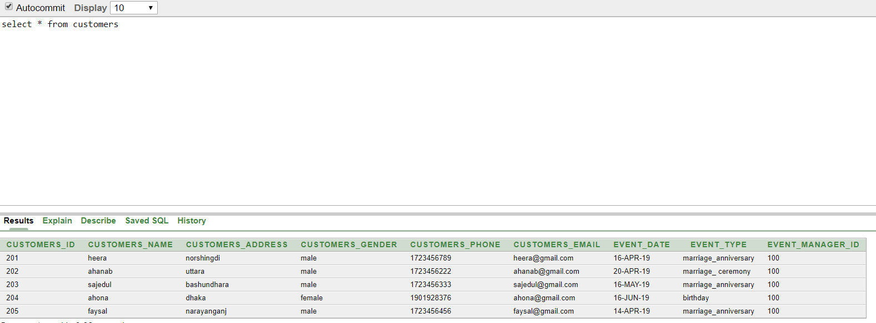

**Event Manager Table**

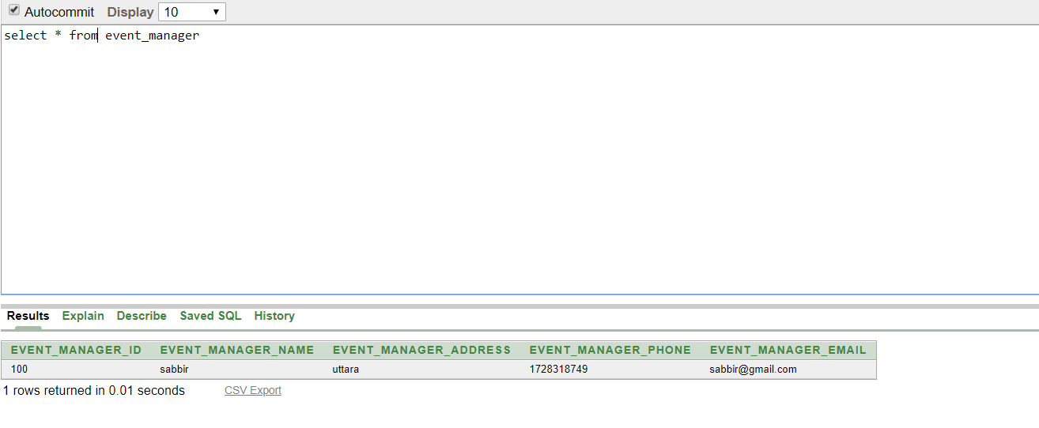

**Planner Table**

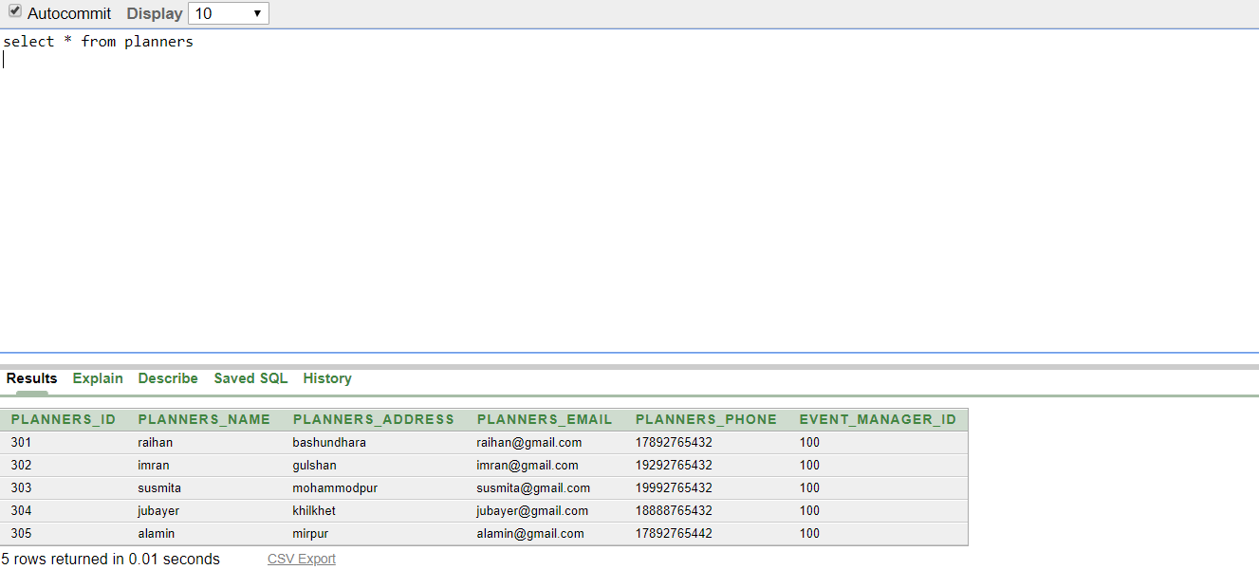

**Caterers Table**

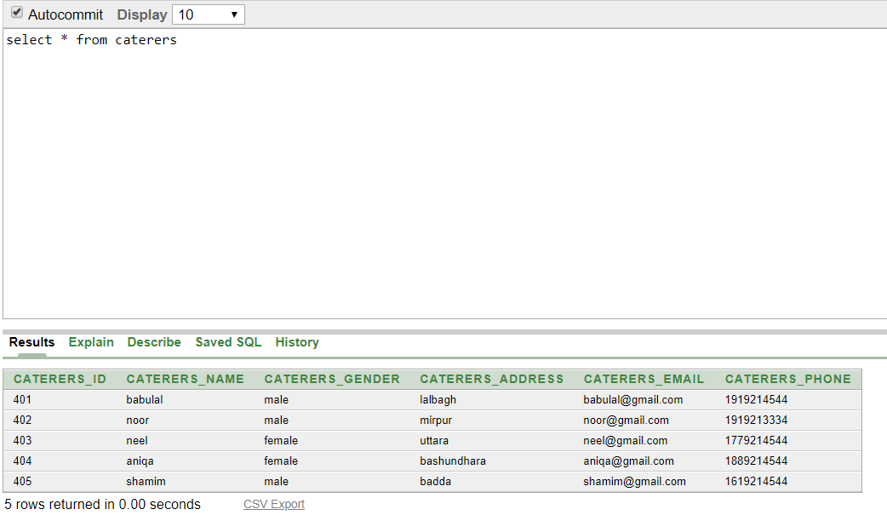

**Planner_caterers Table**

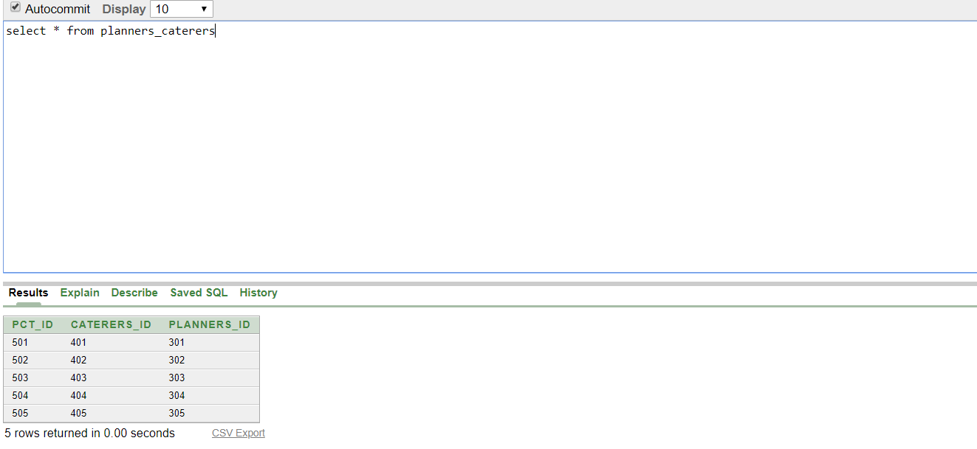

**Photo_videographers**

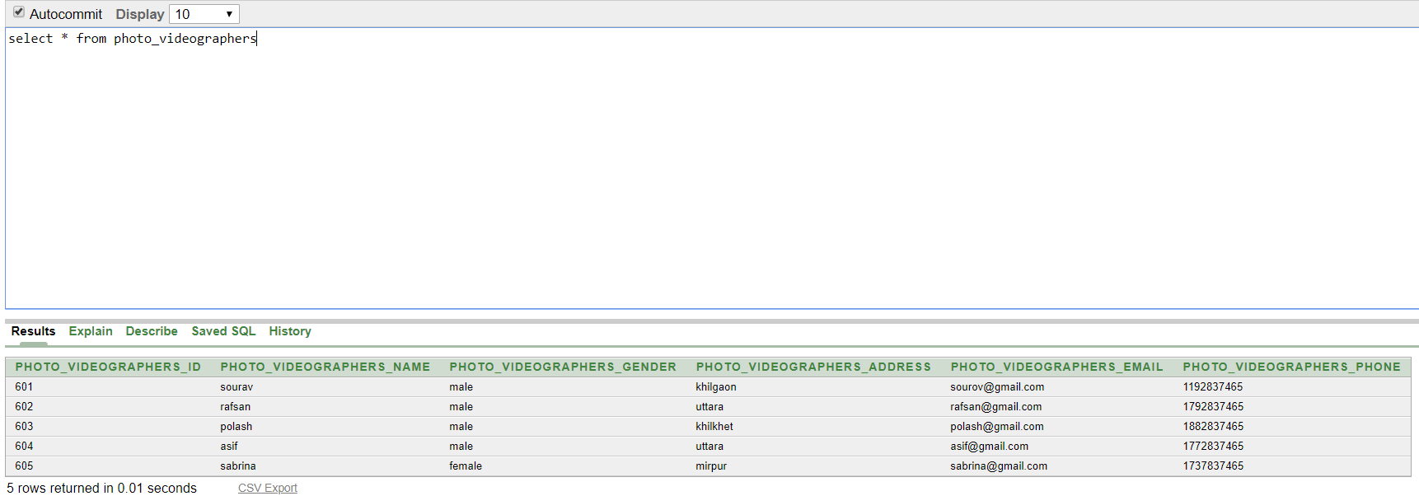

**Planners_photo_videographers**

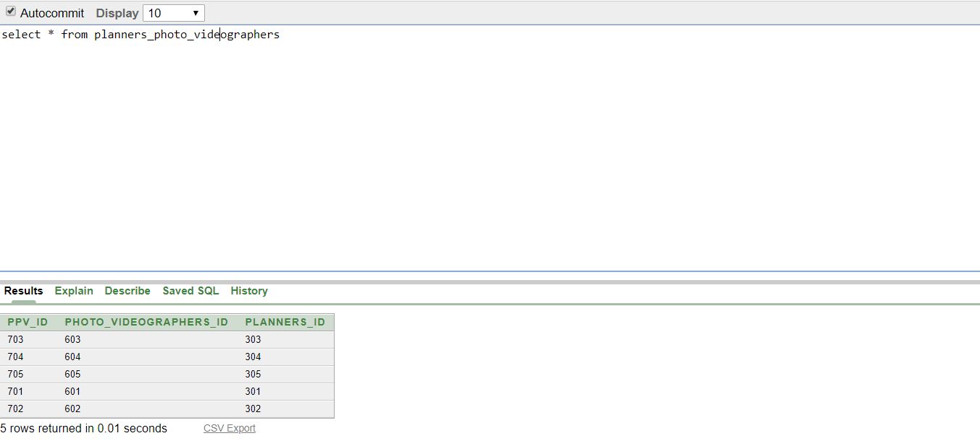

**Decorator Table**

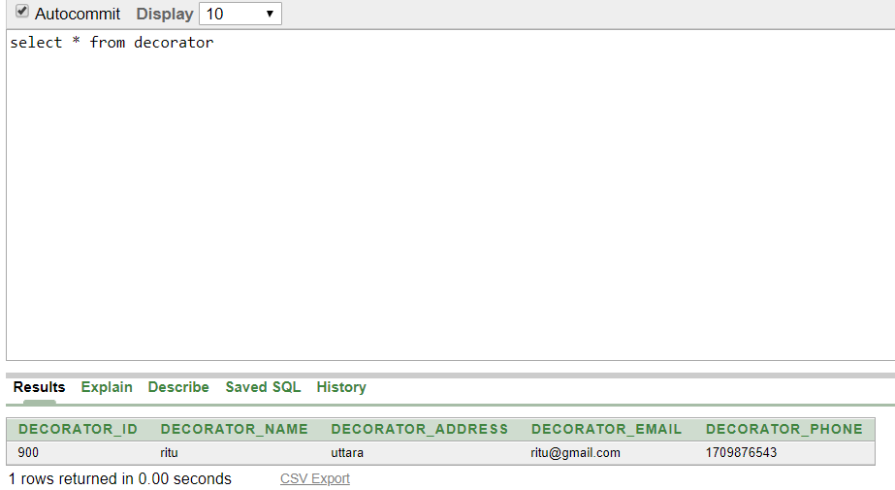

**Planner_Decorator Table**

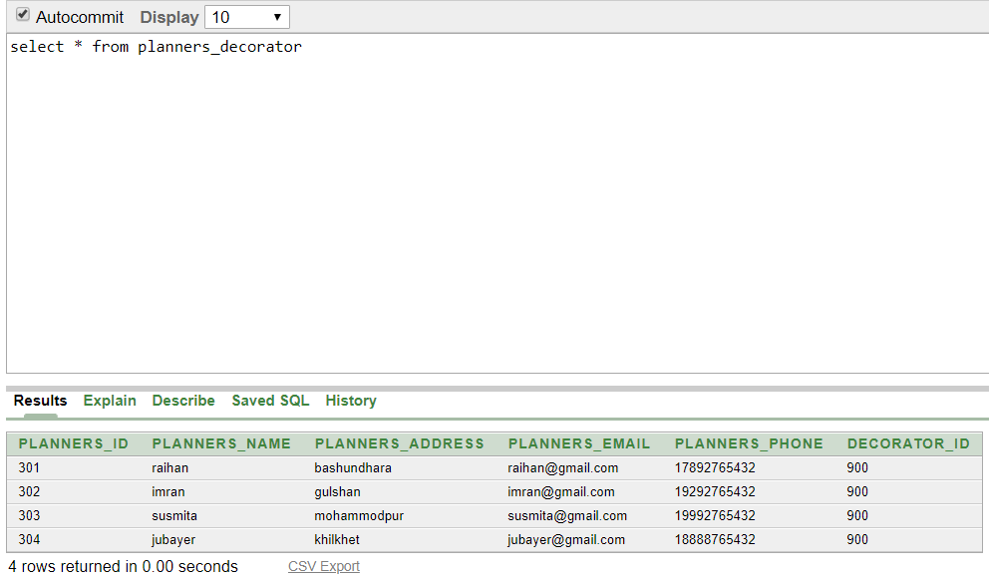

**Florist Table**

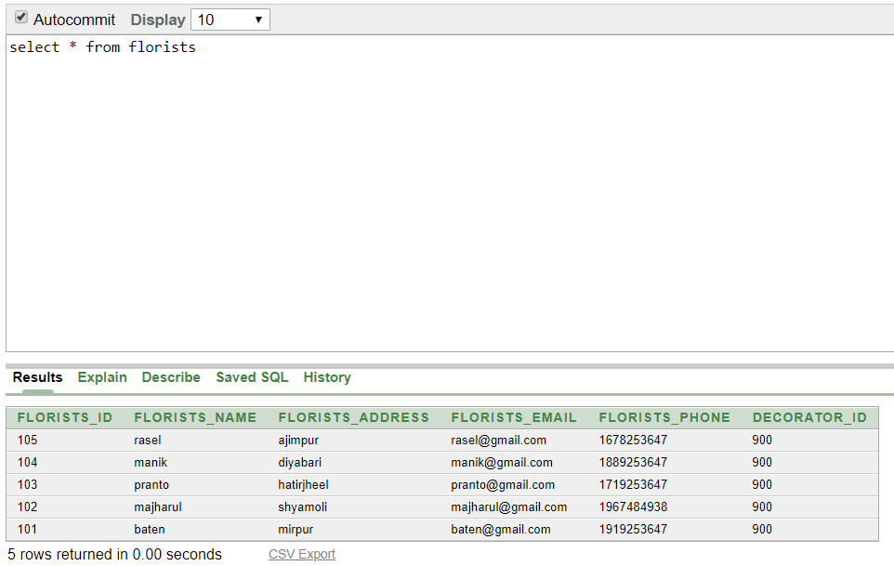

**Lightmans Table**

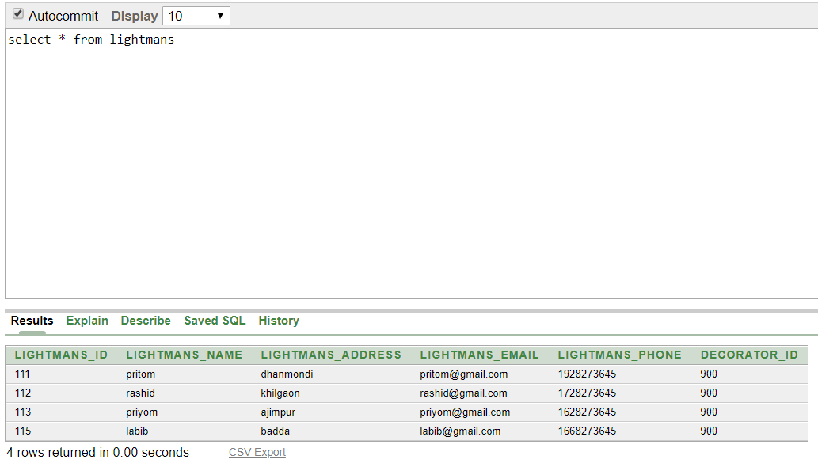

**Electricians Table**

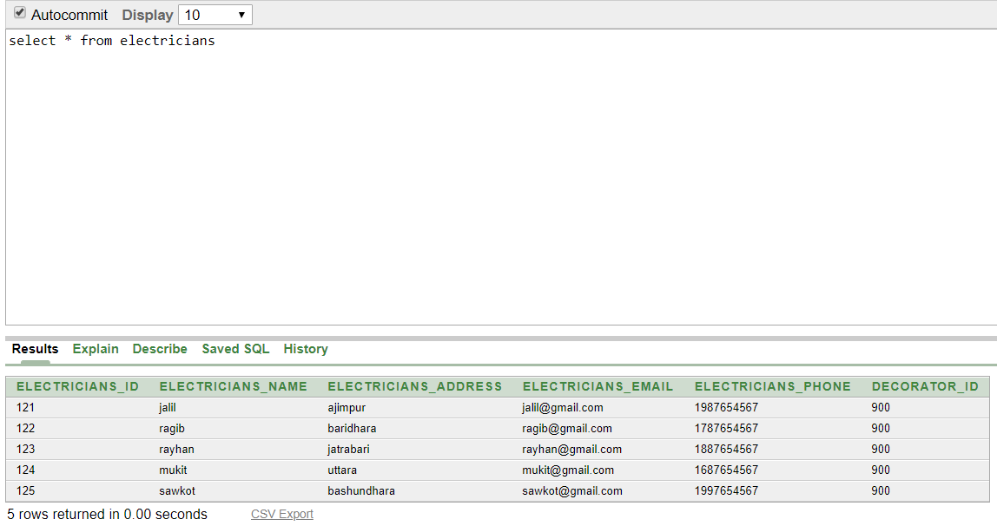

Query Question

1. Display the first name, address and phone of Event manger?
2. Display the ID and email of all planners?
3. Count the planners by manager group?
4. Display the list of light-man by decorator group?
5. Display the name and email all photo/videographer who work under planner id 301
6. Display the planner name who work under the same manager as planner whose first name is jubayer.
7. Write a query in SQL to display the name and phone number for each planner ?
8. Write a query in SQL to display the email and address for each photo/videographer?
9. Create a view called Pl_VU based on the planners phone number and email from planners table .Change the heading for phone to contact number?
10. Create a view called fl_VU based on the florists phone number ,address for all florist .Display the contents of the FL_VU?